**MODULE 4**

**MARKETING MANAGEMENT**

THE 5 Ps OF MARKETING

Marketing involves all activities that a business undertakes to bring attention to their product, and reach and influence their customers. The Marketing Mix or 5 Ps of Marketing comprise product, people, price, place, and promotion. It is an effective template to help guide your marketing efforts.

**01. Product**

This is about ensuring that your product or offering addresses a problem, and you understand how your product stands out from the competition. What is your unique value proposition? Don’t just convey the characteristics of your product (e.g. 2.5 litre engine or low calories); do highlight the benefits (e.g. the thrill of driving or losing weight). Consider the design of the product and packaging. You may have to adjust your product, depending on the market.

**02. People**

Know which customers to target, who best to partner with (e.g. wholesalers versus distributors), and have the right staff. To sell or export your product, you must know your target customers  
well – segment them! Segmenting means honing in on a particular group or demographic (e.g. young high-income professionals). Research their needs, their taste and buying behaviour, so you know how to reach and influence them. Know who might best distribute your product and build your brand. You will also need to train your staff, so they conduct themselves appropriately when interacting with customers.

**03. Price**

Pricing your product is crucial. If you price too high, no one might see the value of your offering.  
If you price too low, you may not be able to recover your costs. When choosing a price, you must identify all the cost, determine your objective (such as gain market-share or establish a position), determine what the market would be willing to pay, and consider your competitors. There are various strategies that could be applied, including value-based, skimming, dynamic, or penetration pricing.

**04. Place**

Consider where you sell (e.g. brick & mortar or on-line store), and where you conduct the rest of your operations or supply chain (e.g. source supplies or warehousing) to ensure these meet the expectations of your customers. Whether physically or virtually (through e-commerce), ensure that the look of your shop reflects your brand, it is accessible, provides all the necessary information, that transacting or making payments are easy, and you have a favourable customer returns process.

**05. Promotion**

This relates to activities that goes into promoting your product or service. It includes sales promotion, digital marketing, publicity, international trade fairs, direct marketing, advertising, sponsorship, social media and Search Engine Optimization. As promotion activities can be expensive, it is important that you do your research on your audience and on the appropriate channel to reach them. These days marketing through social media is a must – it extends your reach and can be particularly targeted – but it can be complex. Also, remember that your messaging must match your brand.

1. **Product life cycle (PLC) Introduction:**

Any product being launched in market has its own life, goes through different cycles. All products go through the main four stages which are **Introduction, Growth, Maturity & Decline** and this process is known as **the product life cycle.** Normally the product life cycle focuses on four main stages, excluding the product development.

**Definition:**

The product life cycle defined by Kotler & Armstrong is the;

**“The product life cycle is course of a product’s sales and profits over its lifetime. It involves five distinct stages: product development, introduction, growth, maturity and decline”.**

or

Dibb et al.simplified the definition by stating that;

**“The product life cycle is about the four main stages for products: introduction, growth, maturity and decline”.**

After the product is being developed and if it is worth it, the product is introduced into the market, at is grows, it gains more customers and with time, the market stabilizes and the product becomes mature. The last stage is the decline stage where the product is being overtaken by rivals and may be withdrawn from the market.

**PLC Concept is Based on Four Premises**

1. **Products have a limited life.**

2. **Product sales pass through distinct stages, each with different marketing implications.**

3. **Profits from a product vary at different stages in the life cycle.**4. **Products require different strategies at different life cycle stages.**

The diagram below shows the different stages of the Product Life Cycle, starting from development to decline.

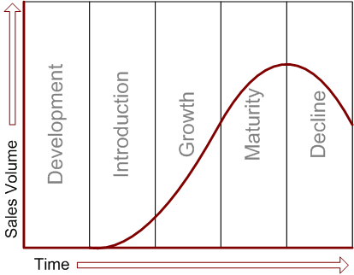

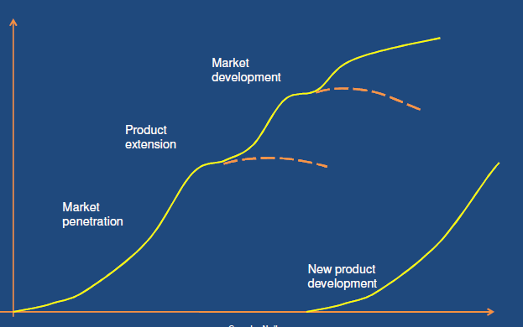page3image1039458000

Generally product life cycle may include Product development, Introduction, Growth, Maturity & Decline, but Actually it include main 4 stages are:

1. Introduction,   
2. Growth,  
3. Maturity &

4. Decline.

**Product development:**

At this stage of the product life cycle, research and design are being carried out to set up a new product. There are different ideas that are being developed and tested and if an idea seems to be reliable, a prototype of the product will be produced. After many tests are being undertaken on the prototype, the firm will decide whether to launch the product or not. Most of the time, some prototypes will fail and will not be able to make it to the next stage. During the development stage, organizations have to take risk and costs and time are massively spent while no revenue will be received.

The development stage will begin with an understanding of what customers are looking in a new product in terms of uses and benefits. A description of the product will be developed and it will include its uses and benefits. Furthermore, an analysis will also be carried out in order to determine the feasibility of the product.

Research has proved that over 80 percent of all new products fail as companied are unable to identify the needs of customers before developing a new product. Organizations should ensure, through effective test marketing, that their new products meet the needs of the customers and have strong advantages over competing products before entering the introduction stage.

**1. Introduction**

At this stage, the new product is being launched after development is complete.

It is defined as the;

**“The product’s first appearance in the marketplace, before any sales or profits has been made”.**

Customers first see or hear about the new product which is being displayed, for example, in stores. An example of a product which is in the introduction stage is Smart Watches, 3D TVs etc.

There are different goals associated with the introduction stage. One of the goals can be to attract customers by making them aware of the new product through **intensive advertising.**

The type of advertising that will be used will depend on the type of product. If the product is aimed at a limited or small public, the advertising campaigns will be smaller. Another goal can be to make customers try the product through different sales tools and pricing activities.

Companies can offer free samples of the new product to customers so that they know how to use it. Organizations can also use one or two pricing strategies such as discount prices on the new products. Normally, organizations tend to incur high costs and make heavy use of promotion. The length of the introduction stage will vary, depending on the types of products being launched. Some products may have a long introduction period while others may have a short one and experience immediate high sales.

Several characteristics are associated to this stage.

1. Sales are low
2. Costs incurred such as promotion and distribution are high
3. The Production process is new
4. Need to inform customers about the new product
5. Experiencing customers

Some strategies that organizations make use of during this stage are as follows:

* Create product awareness and encourage product trial
* Introduce basic products
* Use price skimming or price penetration
* Advertise and promote sales to end-users and dealers
* Build selective distribution outlets

After the product has been launched, the organization needs to continuously asses the product and its environment in order to determine the success of that product. **Some products may fail during the introduction stage and this represents a massive loss for the organization.** The costs incurred are higher as more capital has been spent on marketing and distribution compared to the development stag

**2. Growth:**

The next stage is growth and occurs after a product has survived the introduction stage. Dibb et al. (1997) defined it as the;

**“The stage at which a product’s sales rise rapidly and profits reach a peak, before levelling off into maturity”.**

It is marked by rapid increase in sales and profits of the new product. Customers start liking the product, willing to buy it and refer it to their relatives, friends or colleagues.

A good example is the Blue Ray players, Smart watches etc.

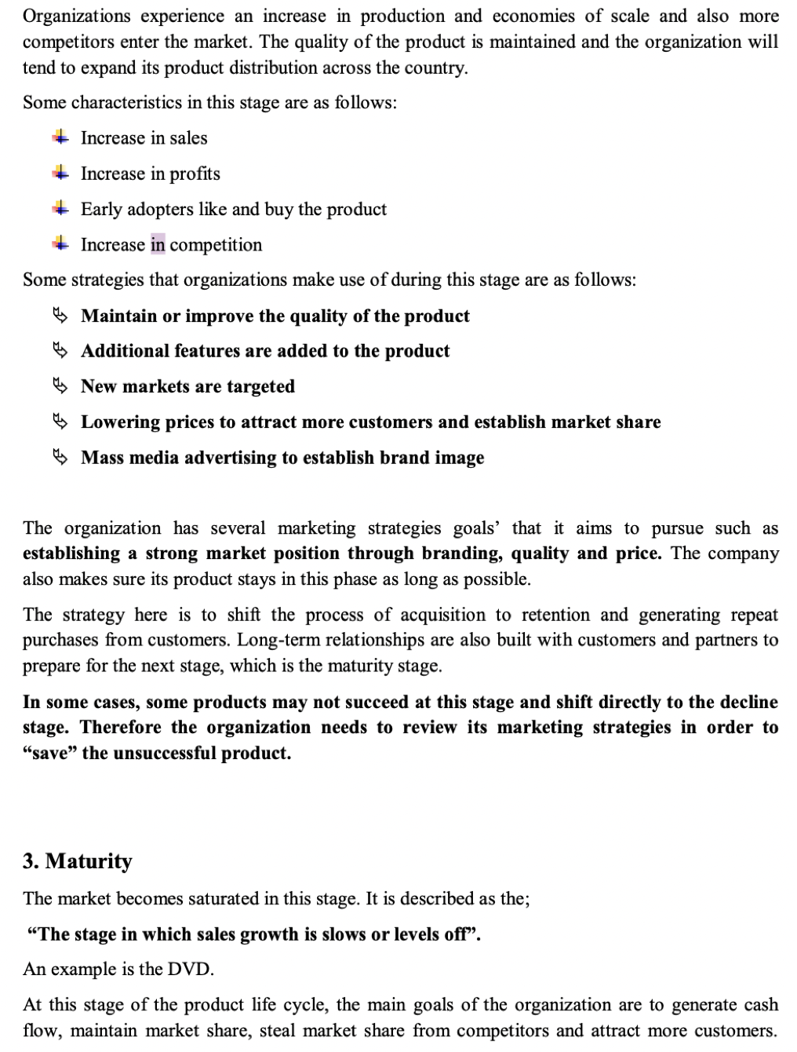

Since competition is fierce, some weaker competitors are unable to continue with their product or they switch their attentions to other products.

Compared to the previous stages, this one lasts longer and marketing managers need to manage the problem of marketing the mature product.

Several characteristics are present at this stage: Most buyers are repeat ones

More intense competition

Aggressive promotional and pricing strategies to capture market share or maintain the market share

Some products become more standardized. Several strategies are available to the company;

* It may lower prices to capture more customers or market share.
* It may also develop new product features to differentiate its products from competitors. The organization can have recourse to quality improvement in order to increase the functional performance of the product. Firms can also improve the features, style, durability, convenience, safety, style and reliability of the product.
* The firm can also lower its unit costs in order to maximize profits and use the money earned to conduct research and development. This will allow the firm to come up with new product ideas to replace the maturing products.
* The organization can use either the defensive or offensive strategies. Defensive strategies include promotions, special sales and so on to maintain market share. Offensive strategies, on the other hand, include re-launching the product, change in the price of the product or adding more features to the product.
* The company can also work on expanding the number of brand users and this can be achieve by winning customers from competitors or entering new market segments
* The elements of marketing mix can also be modified. The firm can review the other elements such as price, promotion, place and so on. It may decrease its price to increase sales, may increase the number of outlets, spend more on advertising and provide better customer service.

**4. Decline**

Decline is the last stage of the product life cycle and in this stage, **sales are low, revenues are decreased, investment is minimized**, customers move to other products and some companies even leave the industry.

Kotler & Armstrong defined it as the;

**“Decline is the stage in which a product’s sales decline”.**

An example is the Video Cassette Recorder.

Some reasons behind these situations are shifts in consumer tastes and increased in domestic and foreign competition.

Several strategies are available to the company;

* Reduce the number of products they offer,
* Reduce their promotion budget and prices as well,
* Either postpone the decline or accept the decline,
* Harvesting or divesting

During the decline stage, a firm can either postpone the decline or accept the decline. If the firm decides to postpone the decline, several choices are available. **The firm may stimulate by repositioning the product, develop new features for the product or make use of advanced technology**. This requires a lot of time and investment and not all firms can afford it and these firms will have to accept the decline stage.

Firms can also have recourse to harvesting or divesting.

**Harvesting implies the gradual reduction in marketing expenditures and the use of a less resource-intensive marketing mix.**

**Divesting on the other hand is the withdrawal of all marketing support from the product. The product is either continued to be sold until it sustains losses or sold to another company.**

Before deciding on the proper marketing strategy to be used during the decline stage, there are many factors that the firm should consider. If the firm has loyal customers who continue to buy the product, it should postpone the decline. If a product has a solid image, in a leading market position, it means that profits are being generated and this also can postpone the decline.

The firm should consider these factors and take the appropriate decisions during the decline stage. Firms should focus on the changes in the market, not on its product.

**MARKETING STRATEGY**

* Marketing has seen its strategic role growing over the years. The question for each organisation is whether the CMO (chief marketing officer) and his or her team have a seat at the strategy table or are relegated to being tactical implementers of tasks such as managing the advertising program. The view that marketing is tactical is changing; it is now more and more frequently being accepted as being part of the strategic management of the organisation. Given the definition of a business strategy and the structure of strategic market management, the roles that marketing can and should play become clearer.
* One marketing role is to be the primary driver of the strategic analysis. The marketing group is in the best position to understand the customers, competitors, market and submarkets, and environmental forces and trends. By managing marketing research and market data, it controls much of the information needed in the external analysis. Marketing should also take the lead in the internal analysis with respect to selected assets (such as the brand portfolio and the distribution channel) and competencies (such as new product introduction and the management of sponsorships).
* A second role is to drive growth strategy for the firm. Growth options are either based on or dependent on customer and market insights, and marketing therefore should be a key driver. In fact, a study by Booz Allen and Hamilton of some 2,000 executives found that a small but growing number of firms (9 percent) describe the CMO as a growth champion involved in all strategic levers relating to growth.5
* A third role is to deal with the dysfunctions of product and geographic silos. Although all functional groups need to deal with this problem, marketing is often on the front lines. The corporate brand and major master brands usually span silos, and a failure to exercise some central control and guidance will result in inefficiencies and inconsistencies that can be damaging to one or more business strategies. Business-spanning marketing programs such as sponsorships or distribution channels need to be actively managed if opportunities are to be realised and waste and inefficiency are to be avoided.
* A fourth role of marketing is to participate in the development of business strategies. This role is best understood by detailing the relationship between marketing and business strategies.

**FINANCIAL MANAGEMENT**

Finance management is a fundamental component of any organization’s strategy and operations. It involves planning, organizing, directing, and controlling financial activities to ensure that resources are allocated efficiently and objectives are met. Effective finance management enables organizations to make informed decisions, manage risks, and secure long-term growth and stability.

Key elements include:

* **Financial Planning:** Establishing short- and long-term goals and determining the necessary resources to achieve them.
* **Budgeting:** Allocating funds across various departments and projects while monitoring expenditures.
* **Investment Decisions:** Assessing potential projects or opportunities to maximize returns.
* **Risk Management:** Identifying and mitigating financial risks to protect the organization’s assets.
* **Performance Evaluation:** Regularly reviewing financial performance to ensure alignment with strategic goals.

**1. Personal Finance**

**Definition:**  
Personal finance involves managing an individual’s or household’s money. It includes budgeting, saving, investing, managing debt, and planning for long-term financial goals.

**Budgeting and Expense Management**:  
Creating a plan for income and expenses to ensure that spending aligns with financial goals.  
*Example:* Using apps like Mint or YNAB (You Need A Budget) to track monthly spending and set savings goals.

* **Savings and Investments:**  
  Setting aside funds for emergencies, future purchases, or retirement.  
  *Example:* Contributing regularly to an emergency fund or investing in retirement accounts such as a 401(k) or an IRA.
* **Debt Management:**  
  Handling liabilities like credit card debt, student loans, or mortgages.  
  *Example:* Prioritizing high-interest debts through a debt snowball or avalanche method to reduce overall interest payments.
* **Insurance and Risk Management:**  
  Protecting against unforeseen events with health, life, or property insurance.  
  *Example:* Purchasing health insurance to cover medical expenses or life insurance to secure family finances in case of an untimely death.
* **Retirement Planning:**  
  Estimating future needs and saving accordingly to ensure financial stability after retirement.  
  *Example:* Planning for retirement by investing in diverse assets to build a retirement corpus over time.

**2. Corporate Finance**

**Definition:**  
Corporate finance deals with managing the financial activities of companies, focusing on maximizing shareholder value through long-term and short-term financial planning and the implementation of various strategies.

**Key Areas:**

* **Capital Budgeting:**  
  Evaluating and selecting long-term investments that are in line with the company's goals.  
  *Example:* A manufacturing company deciding whether to invest in a new production facility based on projected cash flows and profitability.
* **Capital Structure Management:**  
  Determining the best mix of debt and equity financing to fund the company’s operations and growth.  
  *Example:* A startup choosing between issuing shares or taking on bank loans to finance its expansion.
* **Working Capital Management:**  
  Managing the company’s short-term assets and liabilities to ensure sufficient liquidity for day-to-day operations.  
  *Example:* A retail chain managing its inventory and accounts receivable to maintain smooth operations during seasonal fluctuations.
* **Dividend Policy:**  
  Deciding how much profit to return to shareholders versus reinvesting back into the company.  
  *Example:* A mature company like Coca-Cola distributing regular dividends to its shareholders while reinvesting part of its earnings in growth initiatives.
* **Risk Management:**  
  Identifying and mitigating financial risks such as market fluctuations, interest rate changes, or credit risk.  
  *Example:* A multinational corporation using hedging strategies to protect against foreign exchange risks when operating in different currencies.

**3. Public Finance**

**Definition:**  
Public finance involves the management of a country’s or region’s revenue, expenditures, and debt load through various government institutions and policies. It is crucial for funding public services and infrastructure.

**Key Areas:**

* **Government Revenue:**  
  Raising funds through taxes, fees, and other sources.  
  *Example:* Income tax, sales tax, and corporate tax collected by governments to finance public services.
* **Government Expenditure:**  
  Allocating funds to various public sectors such as education, healthcare, and infrastructure.  
  *Example:* A city government using tax revenue to build and maintain public transportation systems or schools.
* **Fiscal Policy:**  
  Using government spending and taxation to influence the economy.  
  *Example:* During an economic downturn, a government might increase spending or cut taxes to stimulate growth (a policy seen in many countries during recession periods).
* **Debt Management:**  
  Issuing bonds or taking loans to finance public projects while managing the overall debt level.  
  *Example:* The U.S. Treasury issuing bonds to raise funds for government projects while managing national debt levels.

**4. International Finance**

**Definition:**  
International finance covers financial transactions that cross international borders. It deals with the movement of capital between countries and the management of currency risks.

**Key Areas:**

* **Foreign Exchange Markets:**  
  Trading currencies and managing exchange rate fluctuations.  
  *Example:* A European company buying U.S. dollars to pay for imported goods and using forward contracts to hedge against currency risk.
* **Cross-Border Investments:**  
  Investing in assets or companies in different countries.  
  *Example:* A U.S.-based investor purchasing shares of a Japanese company, requiring understanding of both local market conditions and international regulations.
* **Global Capital Markets:**  
  Accessing international funding sources through global stock and bond markets.  
  *Example:* A multinational corporation issuing bonds in multiple countries to diversify its investor base and secure lower interest rates.
* **Risk Management in a Global Context:**  
  Addressing risks like political instability, economic fluctuations, and regulatory changes.  
  *Example:* Companies using currency swaps and other financial instruments to mitigate risks associated with operating in politically unstable regions.

**5. Development Finance**

**Definition:**  
Development finance focuses on funding projects that aim to promote economic development and reduce poverty in emerging and developing economies. It is often provided by governments, international organizations, or specialized financial institutions.

**Key Areas:**

* **Infrastructure Projects:**  
  Financing the construction of roads, bridges, water supply, and other critical infrastructure.  
  *Example:* The World Bank funding a major highway project in a developing country to improve trade and connectivity.
* **Social Projects:**  
  Funding initiatives in healthcare, education, and community development.  
  *Example:* International agencies providing grants to build schools and hospitals in underserved regions.
* **Economic Reforms and Capacity Building:**  
  Assisting governments in creating a conducive environment for sustainable economic growth.  
  *Example:* The International Monetary Fund (IMF) providing financial assistance coupled with policy advice to help a country stabilize its economy during a crisis.
* **Microfinance:**  
  Offering small loans and financial services to individuals and small businesses that lack access to traditional banking.  
  *Example:* Microfinance institutions like Grameen Bank lending small amounts to entrepreneurs in rural areas to start or expand their businesses.

Each type of finance serves a distinct purpose, addressing different aspects of economic activity—from individual money management to large-scale government projects. Understanding these differences is crucial for making informed financial decisions whether you’re managing personal funds, steering a corporation, administering public budgets, engaging in international transactions, or spearheading development initiatives.

**Balance Sheet and Profit & Loss Account in Financial Management**

In financial management, the **Balance Sheet** and the **Profit & Loss (P&L) Account** (also called the Income Statement) are two fundamental financial statements used to assess a company's financial health and performance.

**1. Balance Sheet**

The **Balance Sheet** is a financial statement that provides a snapshot of a company’s financial position at a specific point in time. It shows what the company owns (assets) and what it owes (liabilities), along with the owner’s equity.

**Structure of a Balance Sheet**

**A. Assets (What the company owns)**

1. **Current Assets** (Short-term, convertible into cash within a year)
   * Cash and cash equivalents
   * Accounts receivable
   * Inventory
   * Prepaid expenses
2. **Non-Current Assets** (Long-term, used for operations)
   * Property, plant, and equipment (PP&E)
   * Intangible assets (Patents, goodwill)
   * Investments

**B. Liabilities (What the company owes)**

1. **Current Liabilities** (Obligations due within a year)
   * Accounts payable
   * Short-term loans
   * Accrued expenses
2. **Non-Current Liabilities** (Long-term obligations)
   * Long-term loans
   * Bonds payable

**C. Equity (Owner’s claim on assets)**

* Share capital
* Retained earnings
* Reserves

**Balance Sheet Formula:**

Assets=Liabilities+Equity\text{Assets} = \text{Liabilities} + \text{Equity}Assets=Liabilities+Equity

**2. Profit & Loss (P&L) Account (Income Statement)**

The **P&L Account** summarizes a company’s revenues and expenses over a specific period (monthly, quarterly, or annually) to determine profit or loss.

**Structure of a P&L Account**

1. **Revenue (Sales/Income)**
   * Total sales revenue
   * Other income (interest, investments)
2. **Cost of Goods Sold (COGS)**
   * Direct expenses related to production
3. **Gross Profit**

Gross Profit=Revenue−COGS\text{Gross Profit} = \text{Revenue} - \text{COGS}Gross Profit=Revenue−COGS

1. **Operating Expenses**
   * Salaries
   * Rent
   * Marketing expenses
2. **Operating Profit (EBIT – Earnings Before Interest & Tax)**

EBIT=Gross Profit−Operating Expenses\text{EBIT} = \text{Gross Profit} - \text{Operating Expenses}EBIT=Gross Profit−Operating Expenses

1. **Net Profit Before Tax**

EBIT−Interest Expenses\text{EBIT} - \text{Interest Expenses}EBIT−Interest Expenses

1. **Net Profit After Tax (NPAT)**

Net Profit=Net Profit Before Tax−Taxes\text{Net Profit} = \text{Net Profit Before Tax} - \text{Taxes}Net Profit=Net Profit Before Tax−Taxes

**Key Differences Between Balance Sheet & P&L Account**

| **Aspect** | **Balance Sheet** | **Profit & Loss Account** |
| --- | --- | --- |
| Purpose | Shows financial position at a specific time | Shows performance over a period |
| Components | Assets, Liabilities, Equity | Revenues, Expenses, Profits |
| Timing | Snapshot (specific date) | Flow statement (over time) |
| Usage | Determines solvency and liquidity | Measures profitability |

**Importance in Financial Management**

* **Balance Sheet** helps in assessing **financial stability** and **liquidity**.
* **P&L Account** helps in evaluating **profitability** and **performance** over time.
* Both statements are used by investors, lenders, and management for decision-making.

**Working Capital in Financial Management**

**Working Capital** is a key financial metric that measures a company’s short-term financial health and operational efficiency. It represents the difference between a company's **current assets** and **current liabilities** and indicates its ability to cover short-term obligations.

**1. Definition of Working Capital**

Working Capital=Current Assets−Current Liabilities\text{Working Capital} = \text{Current Assets} - \text{Current Liabilities}Working Capital=Current Assets−Current Liabilities

* **Positive Working Capital**: The company has enough short-term assets to cover its short-term liabilities, indicating financial stability.
* **Negative Working Capital**: The company may struggle to meet short-term obligations, which can lead to liquidity issues.

**2. Components of Working Capital**

**A. Current Assets (Short-term assets that can be converted into cash within a year)**

* Cash and cash equivalents
* Accounts receivable (money owed by customers)
* Inventory (raw materials, work-in-progress, finished goods)
* Marketable securities
* Prepaid expenses

**B. Current Liabilities (Short-term financial obligations due within a year)**

* Accounts payable (money owed to suppliers)
* Short-term loans
* Wages payable
* Taxes payable
* Accrued expenses

**3. Importance of Working Capital in Financial Management**

* **Liquidity Management**: Ensures a company has enough cash to pay its short-term obligations.
* **Operational Efficiency**: Helps in maintaining smooth day-to-day business operations.
* **Profitability & Growth**: Optimal working capital management can improve cash flow and reinvestment in growth.
* **Solvency & Risk Management**: Prevents financial distress and bankruptcy.

**4. Types of Working Capital**

1. **Gross Working Capital (GWC)**
   * The total value of a company's current assets.
2. **Net Working Capital (NWC)**
   * The difference between current assets and current liabilities.
3. **Permanent Working Capital**
   * The minimum level of working capital required for continuous business operations.
4. **Temporary (Variable) Working Capital**
   * The fluctuating working capital needed due to seasonal demand or business cycles.

**5. Working Capital Management Strategies**

1. **Conservative Approach**
   * Higher levels of current assets, lower financial risk.
   * May lead to idle cash and lower returns.
2. **Aggressive Approach**
   * Lower levels of current assets, higher returns but higher risk.
3. **Moderate Approach**
   * A balanced approach between risk and liquidity.

**6. Key Working Capital Ratios**

**A. Current Ratio**

Current Ratio=Current AssetsCurrent Liabilities\text{Current Ratio} = \frac{\text{Current Assets}}{\text{Current Liabilities}}Current Ratio=Current LiabilitiesCurrent Assets​

* Measures a company's ability to pay short-term obligations.
* A ratio of **1.5 to 2** is generally considered healthy.

**B. Quick Ratio (Acid-Test Ratio)**

Quick Ratio=Current Assets−InventoryCurrent Liabilities\text{Quick Ratio} = \frac{\text{Current Assets} - \text{Inventory}}{\text{Current Liabilities}}Quick Ratio=Current LiabilitiesCurrent Assets−Inventory​

* Excludes inventory since it is not always easily convertible to cash.
* A ratio of **1 or above** indicates good liquidity.

**C. Working Capital Turnover Ratio**

Working Capital Turnover=Net SalesAverage Working Capital\text{Working Capital Turnover} = \frac{\text{Net Sales}}{\text{Average Working Capital}}Working Capital Turnover=Average Working CapitalNet Sales​

* Measures how efficiently a company uses its working capital to generate revenue.

**7. Example Calculation**

A company has the following financial data:

* **Current Assets**: $500,000
* **Current Liabilities**: $300,000

**Working Capital Calculation**

Working Capital=500,000−300,000=200,000\text{Working Capital} = 500,000 - 300,000 = 200,000Working Capital=500,000−300,000=200,000

Since the working capital is positive, the company is in a good financial position.

**Conclusion**

Working capital is crucial for maintaining **financial stability**, **smooth operations**, and **growth**. Effective management of working capital ensures that a company can meet its short-term liabilities while also investing in opportunities for expansion.

**International Finance in Financial Management**

**1. What is International Finance?**

**International finance** is a branch of financial management that deals with monetary interactions between two or more countries. It involves cross-border transactions, exchange rates, foreign investments, international trade, and global financial institutions.

With globalization, companies and governments engage in international finance to expand business operations, manage currency risks, and raise capital in foreign markets.

**2. Key Aspects of International Finance**

**A. Foreign Exchange (Forex) and Exchange Rates**

* **Exchange rate**: The price of one currency in terms of another (e.g., 1 USD = 80 INR).
* **Types of exchange rates**:
  + **Fixed exchange rate** (controlled by government/central bank).
  + **Floating exchange rate** (determined by market supply and demand).
  + **Pegged exchange rate** (fixed but adjusted periodically).
* **Currency fluctuations** impact business profits, trade balances, and inflation.

**B. Foreign Direct Investment (FDI) and Foreign Portfolio Investment (FPI)**

* **FDI**: Long-term investment by a foreign company (e.g., a U.S. company building a factory in India).
* **FPI**: Investments in stocks, bonds, and financial assets of a foreign country.

**C. International Trade and Payments**

* **Balance of Payments (BOP)**: A record of all economic transactions between a country and the rest of the world.
  + **Current account**: Trade in goods & services.
  + **Capital account**: Investments & financial transfers.
* **Trade barriers**: Tariffs, quotas, and regulations affecting cross-border trade.

**D. Global Financial Institutions**

* **International Monetary Fund (IMF)**: Stabilizes exchange rates and provides financial aid.
* **World Bank**: Provides funding for economic development.
* **World Trade Organization (WTO)**: Regulates international trade.

**E. International Financial Markets**

* **Eurocurrency Market**: Deposits in a foreign currency outside the issuing country (e.g., Eurodollars in London banks).
* **Eurobonds**: Bonds issued in a foreign currency outside the home country.
* **Global Stock Exchanges**: NYSE, NASDAQ, London Stock Exchange, Tokyo Stock Exchange.

**3. Importance of International Finance in Financial Management**

* **Global Expansion**: Helps companies enter new markets.
* **Risk Diversification**: Reduces dependence on one economy.
* **Foreign Exchange Risk Management**: Protects against currency fluctuations.
* **Access to International Capital**: Allows firms to raise funds from foreign investors.
* **Better Investment Opportunities**: Enables investors to earn higher returns.

**4. Challenges in International Finance**

1. **Currency Exchange Risk**: Volatility in exchange rates can impact profits.
2. **Political & Economic Risks**: Changes in government policies, inflation, or recessions affect financial stability.
3. **Regulatory Differences**: Compliance with foreign financial regulations is complex.
4. **Cultural & Ethical Differences**: Different business practices across countries.

**5. Strategies for Managing International Finance Risks**

* **Hedging with Derivatives**: Using forward contracts, options, and swaps to manage currency risks.
* **Diversification**: Investing in multiple countries to spread risks.
* **Using Local Financing**: Borrowing in the local currency to reduce exchange rate risk.
* **Political Risk Insurance**: Protecting against losses due to political instability.

**Conclusion**

International finance plays a critical role in **global trade, investments, and corporate expansion**. Effective financial management in international markets requires **risk assessment, currency hedging, and regulatory compliance** to maximize profitability and minimize financial risks.